RESULTS

CASE 1: CRITICAL DEPRESSION

ORIGINAL SPEECH SIGNAL PLOT:

The figure shows the graph of original speech sample of a critically depressed person.

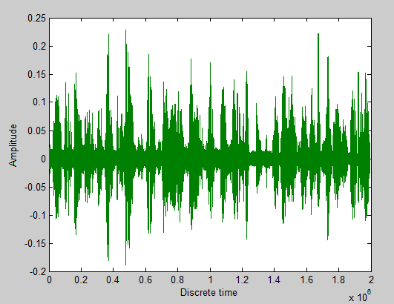

13 MFCC’S PLOT:

The figure shows the plot of 13 MFCC coefficients of a critically depressed person.

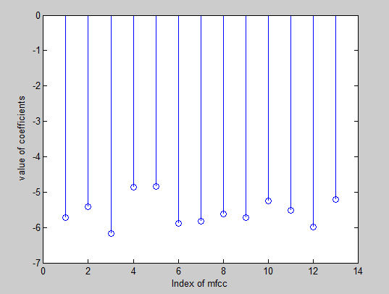

INTENSITY PLOT:

The figure shows the intensity plot of a critically depressed person.

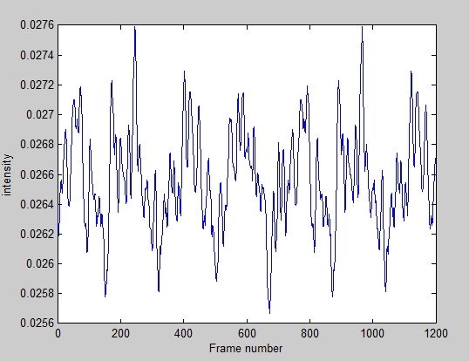

LOUDNESS PLOT:

The figure shows the intensity plot for a critically depressed person.

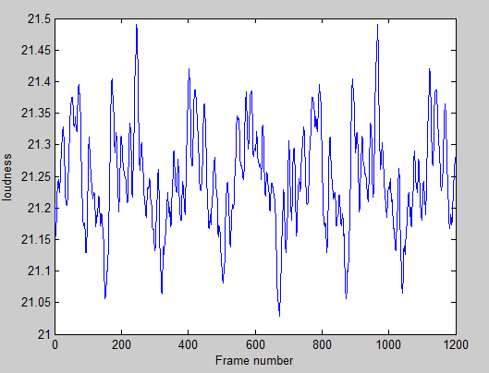

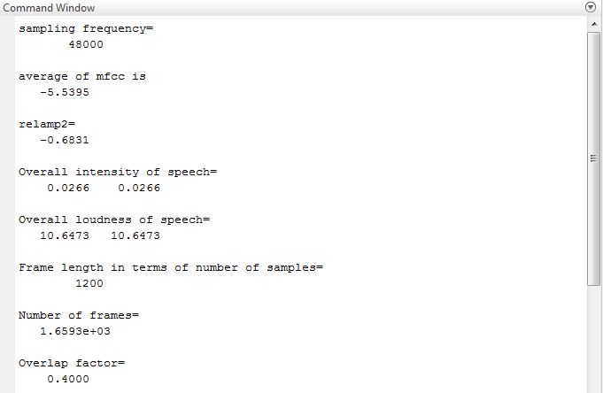

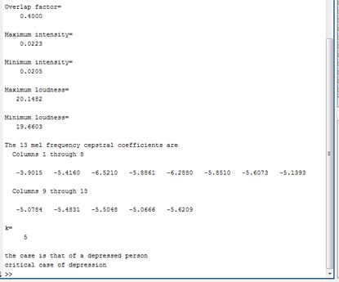

Command window showing results of a critically depressed person**.**

CASE 2: MODERATE DEPRESSION

ORIGINAL SPEECH SIGNAL PLOT:

The figure shows the graph of original speech sample of a moderately depressed person.

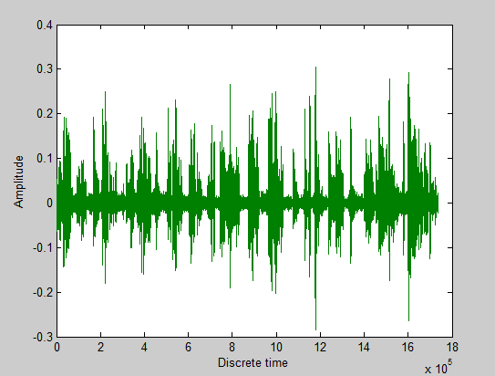

13 MFCC’S PLOT:

The figure shows the plot of 13 MFCC coefficients of a moderately depressed person.

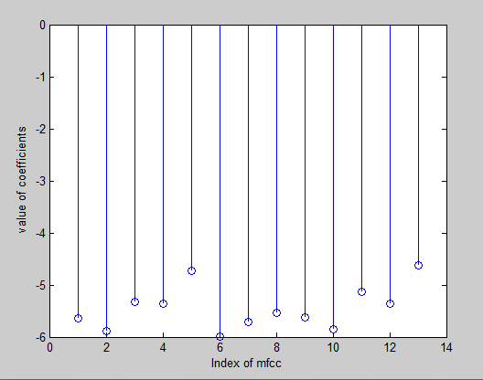

INTENSITY PLOT:

The figure shows the intensity plot of a moderately depressed person.

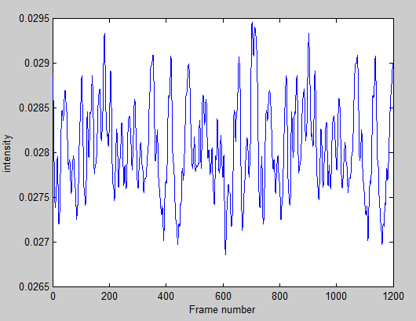

LOUDNESS PLOT:

The figure shows the intensity plot of a moderately depressed person.

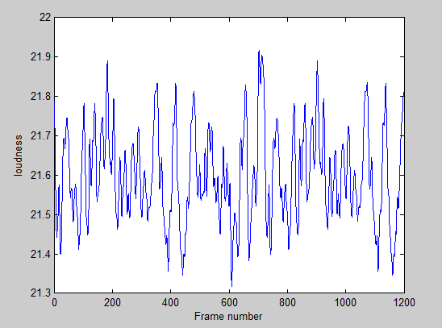

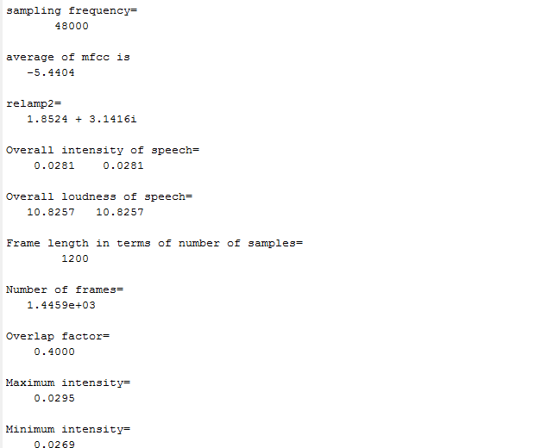

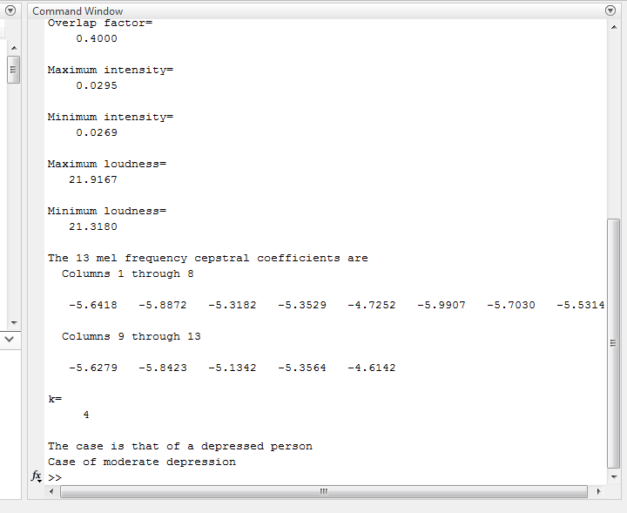

Command window showing results of a moderately depressed person.

CASE 3: NO DEPRESSION

ORIGINAL SPEECH SIGNAL PLOT:

The figure shows the graph of original speech sample of a non-depressed person.

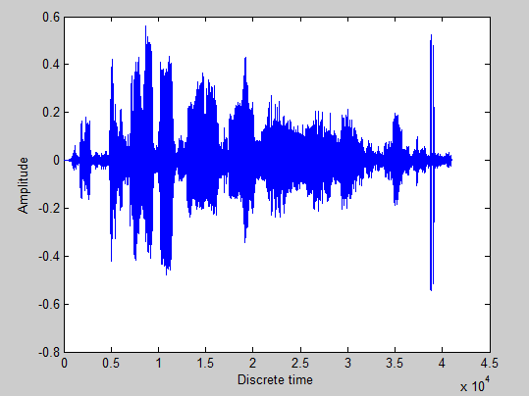

13 MFCC’S PLOT:

The figure shows the plot of 13 MFCC’s of a non-depressed person.

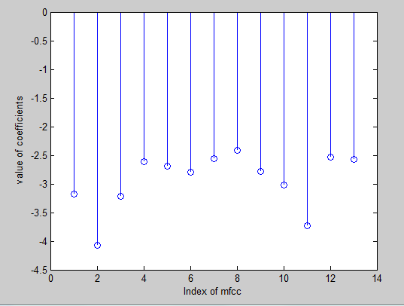

INTENSITY PLOT:

The figure shows the intensity plot of a non-depressed person.

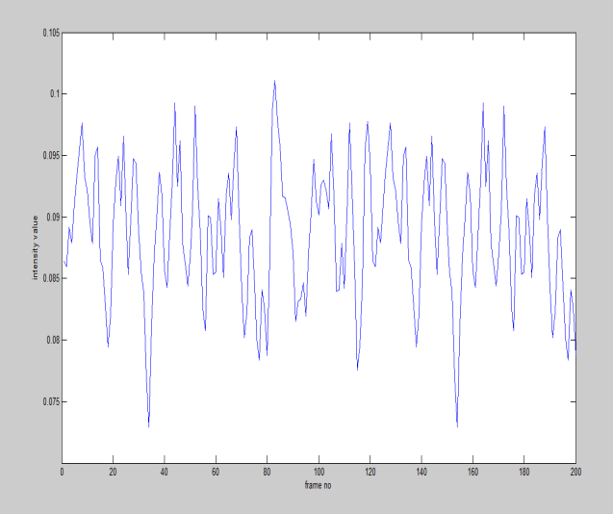

LOUDNESS PLOT:

The figure shows the intensity plot of a non-depressed person.

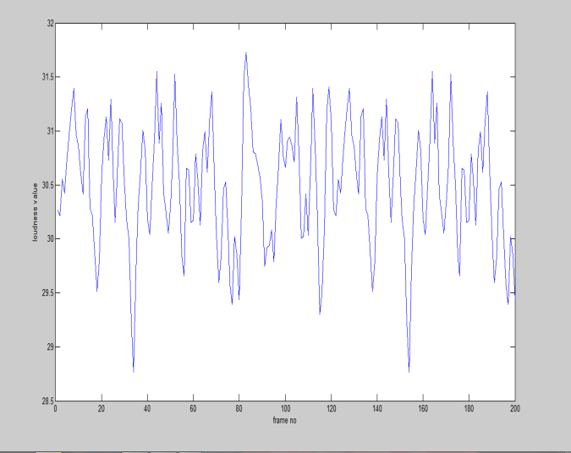

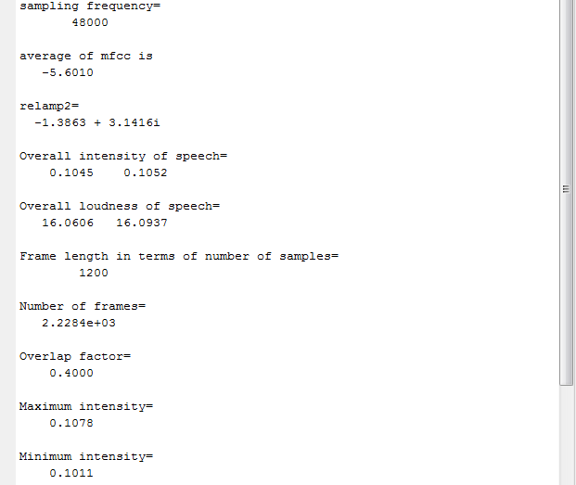

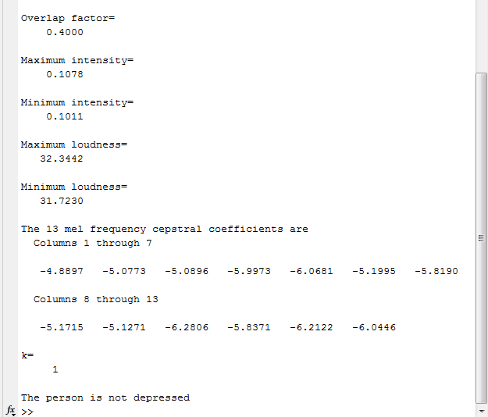

Command window showing results of a non-depressed person.